**AIM:** Design TM using simulator to perform string comparison where w={aba aba}

**INPUT:**

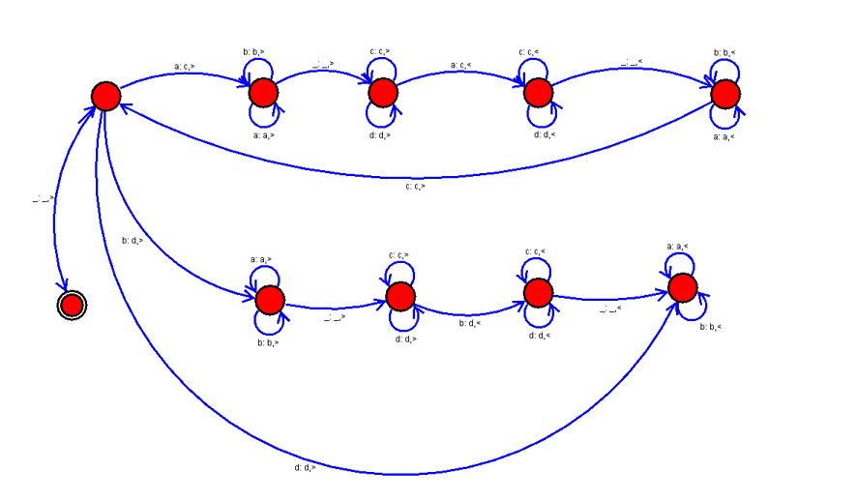**OUTPUT:**

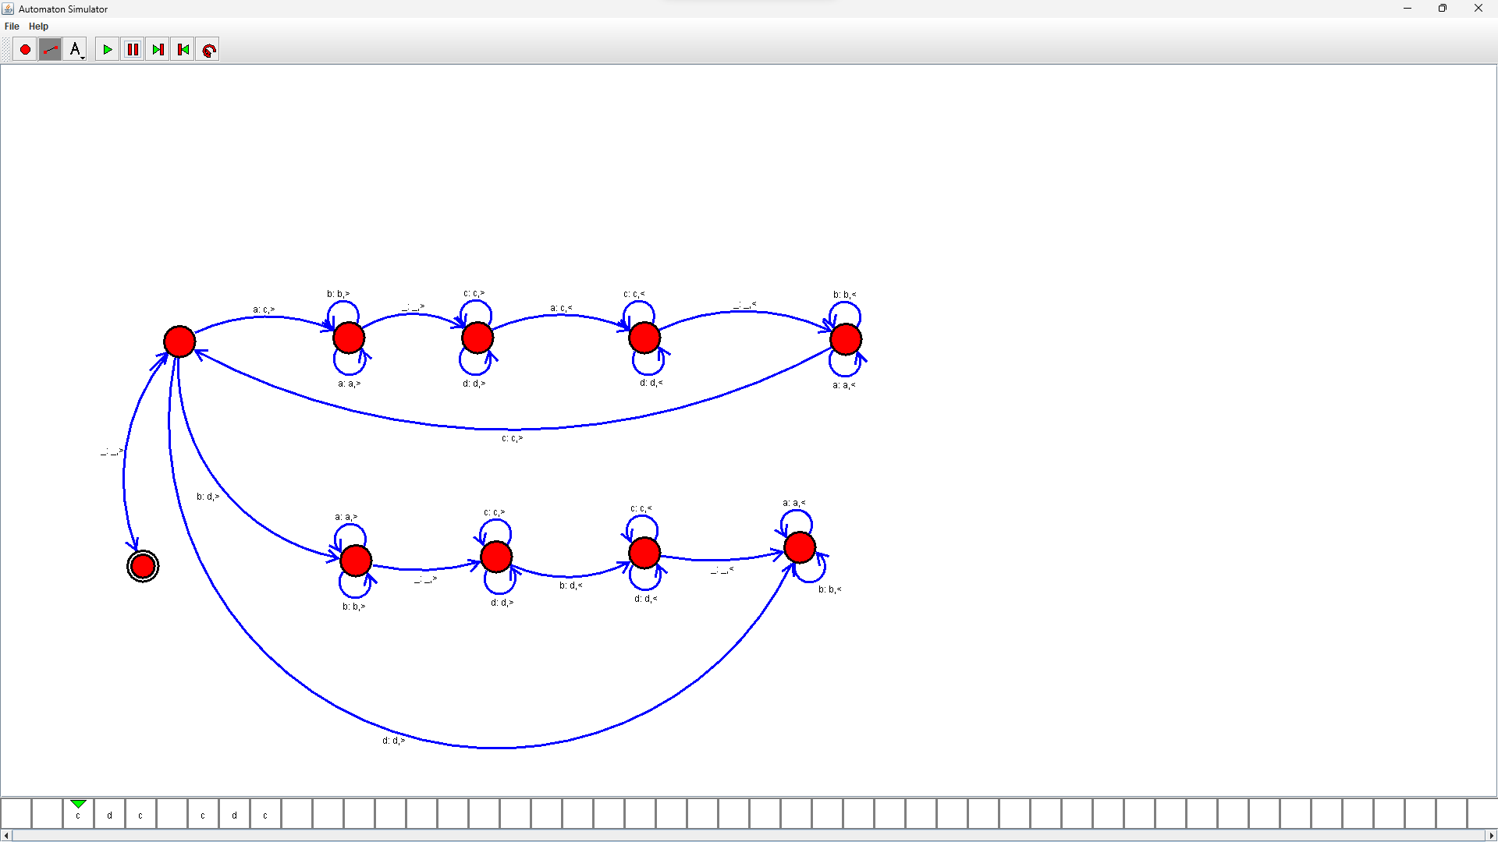

**RESULTS:**

We designed TM using simulator to perform string comparison by using autosim